Galaxy Buds Live

SM-R180NZNAMEA

[**Product Ratings :4.3(Number of Ratings :3227)**](javascript:void(0))

* Ergonomic design
* Active Noise Cancellation for open type
* Live and deep sound

**Looking for alternatives?**

[[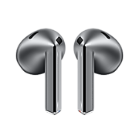](https://www.samsung.com/pk/audio-sound/galaxy-buds/galaxy-buds3-silver-bluetooth-sm-r530nzaamea/)](https://www.samsung.com/pk/audio-sound/galaxy-buds/galaxy-buds3-silver-bluetooth-sm-r530nzaamea/)

[**Galaxy Buds3**](https://www.samsung.com/pk/audio-sound/galaxy-buds/galaxy-buds3-silver-bluetooth-sm-r530nzaamea/)

**Rs. 51,999.00**

[Product Ratings :2.1](https://www.samsung.com/pk/audio-sound/galaxy-buds/galaxy-buds3-silver-bluetooth-sm-r530nzaamea/#reviews)

[**Learn more**](https://www.samsung.com/pk/audio-sound/galaxy-buds/galaxy-buds3-silver-bluetooth-sm-r530nzaamea/)

[[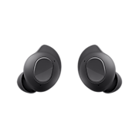](https://www.samsung.com/pk/audio-sound/galaxy-buds/galaxy-buds-fe-graphite-sm-r400nzaamea/)](https://www.samsung.com/pk/audio-sound/galaxy-buds/galaxy-buds-fe-graphite-sm-r400nzaamea/)

[**Galaxy Buds FE**](https://www.samsung.com/pk/audio-sound/galaxy-buds/galaxy-buds-fe-graphite-sm-r400nzaamea/)

**Rs. 33,399.00**

[Product Ratings :4.7](https://www.samsung.com/pk/audio-sound/galaxy-buds/galaxy-buds-fe-graphite-sm-r400nzaamea/#reviews)

[**Learn more**](https://www.samsung.com/pk/audio-sound/galaxy-buds/galaxy-buds-fe-graphite-sm-r400nzaamea/)

Choose your color

**Color :**Mystic Bronze

* 
* 
* 

**Galaxy Buds Live**

Mystic Bronze

[**Where to buy**](javascript:;)

key features

* 

Iconic design

* 

Color

* 

Ergonomic

* [Galaxy  
  Note20 | 20Ultra](https://www.samsung.com/pk/smartphones/galaxy-note20/)
* [Galaxy  
  Buds Live](https://www.samsung.com/pk/audio-sound/galaxy-buds/galaxy-buds-live-mystic-bronze-sm-r180nznamea/)
* [Galaxy  
  Watch3](https://www.samsung.com/pk/watches/galaxy-watch/galaxy-watch3-41mm-mystic-silver-sm-r850nzsamea/)

Galaxy Buds Live





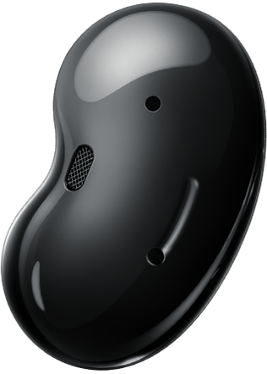

Introducing Galaxy Buds Live

The earbud designed to tune in to every moment. With an iconic shape and ergonomic design, a fit that lets in your natural surroundings, and a speaker optimized for a better experience. This is sound made for your ears.

A design that's unheard of

ICONIC DESIGN

The new iconic shape of true wireless earbuds

Galaxy Buds Live’s eye-catching design stands out, even inside your ear. Reflecting the curves of the ear and face for a natural look, they're polished off with a glossy finish and even come together with a jewelry box-inspired cas